1.0 PURPOSE………….. 1
2.0 SCOPE…………. 1
3.0 reference documents 1
3.1 TI Standard Policy and Procedure (SP&P) 04-04-01: "Environmental, Health and Safety" 1
3.2 TI ESH Standard 01.01, “Personal Protective Equipment” 1
3.3 TI Quality Specification QSS 014-001 “Handling Requirements for Electrostatic Discharge (ESD) 1
4.0 Definitions 1
5.0 Requirements 2
5.1 General Requirements 2
5.2 Requirements for All Electrical Labs 3
5.3 Exposed Energized Work ≥50 Volts AC or ≥100 Volts DC up to 600 Volts AC/DC 4
5.4 Testing at >600 Volts 6
5.5 Testing at >1,000 Volts 6
5.6 Testing at >2,500 Volts 7
5.7 Personal Protective Equipment (PPE) 7
5.8 Insulated Tools and Equipment 8
5.9 Training Requirements for Qualified and Safety Back-up Employees 9
6.0 STANDARD Approval 10
7.0 Revision history 10

PURPOSE
To establish the minimum requirements necessary to implement and maintain safe work practices and procedures in electrical safety for design or test workspaces, including all R&D labs, Engineering labs, and Electronic Failure Analysis labs.

SCOPE
This standard addresses potentially hazardous electrical conditions to persons, working near or with, energized electrical circuitry operating at or in excess of 50 volts. The provisions of this standard apply to all TI employees, suppliers, vendors, and visitors to TI sites worldwide.

reference documents

TI Standard Policy and Procedure (SP&P) 04-04-01: "Environmental, Health and Safety"

TI ESH Standard 01.01, “Personal Protective Equipment”

TI Quality Specification QSS 014-001 “Handling Requirements for Electrostatic Discharge (ESD)

Definitions
TI ESH Standards Glossary of Definitions

Requirements

General Requirements

Work on exposed energized electrical circuitry 50 volts or greater alternating current (AC) or 100 volts or greater direct current (DC)* is prohibited except when de-energizing introduces additional or increased hazards or it is infeasible due to equipment design or operational limitations.
* In the United States the regulation requires 50 volts AC or DC, and the EU standard requires 25 volts AC or 60 volts DC.

Safety-related work practices shall be used to safeguard employees from injury while they work on electrical conductors and circuit parts 50 volts or greater alternating current (AC) or 100 volts or greater direct current (DC) that are or can become energized. The specific safety-related work practices shall be consistent with the nature and extent of the associated electrical hazards.

Only Qualified Persons shall be permitted to work on exposed energized electrical circuitry at 50 volts or greater AC or 100 volts or greater (DC) up to 600 volts.

No exposed work is allowed for voltages greater than 600 volts.

Conductive apparel (such as watch bands, bracelets, rings, key chains, necklaces, etc.) shall be removed before performing work on energized electrical conductors or circuits.

Conductive materials, tools, and equipment that are in contact with any part of an employee’s body shall be handled in a manner that prevents accidental contact with energized electrical conductors or circuit parts.
Such materials and equipment include, but are not limited to, long conductive objects, such as ducts, pipes and tubes, conductive hose and rope, metal-lined rules and scales, steel tapes, and heat-sinks.

Qualified employees shall NOT reach blindly into areas that might contain exposed energized electrical conductors or circuit parts where an electrical hazard exists.

Qualified employees shall avoid reaching into a hazardous voltage setup with two hands unless the setup has been de-energized and verified to be safe, prior to work.

Electro Static Discharge (ESD) Testing Equipment for Semiconductor devices
Note: All the requirements of this standard apply to the device under test (DUT) and must be followed and implemented to protect the person performing the test activities from the electrical hazard(s) of the DUT

All ESD testing equipment must be designed, installed and used following the manufacturers’ instruction.

All ESD testing equipment must be certified by an approved National Recognized Testing Facility (e.g., Underwriters Laboratory) or CE marked.

Any ESD testing equipment capable of producing greater than 100 volts AND greater than 1 joule must be installed in a fail-safe interlock-protected enclosure.

Requirements for All Electrical Labs

Workstations shall be designed to minimize the potential for unintentional exposure. Redundancy is encouraged (e.g., test enclosures, fail-safe interlocking, ground fault detection and circuit interruption, shielding/insulation).

When possible the site shall utilize enclosures that are protected with a fail-safe interlock(s), light curtains or similar engineered protective means to prevent accidental contact with exposed energized parts or components.
The design of the enclosure shall take into account the materials of construction and the limitations of the equipment or components being used within the box (e.g., voltage/current rated devices, FM4910 plastic material).

All new workstations purchased after the effective date of this standard shall be a minimum of 36 inches (0.9 meters) in depth to allow adequate work space for the Qualified employee.

All workstations shall be provided with adequate clearances based on voltage present and exposure at the work station and must meet the local regulatory requirement for egress clearance.

See Appendix A for additional diagrams and details.

All work areas shall establish a method to manage electrical cabling in a neat and orderly fashion.

All workstations shall be uniquely identified and labeled.

Safety signs and safety symbols shall be used at the entrance to all work areas to warn employees about the electrical hazards that might endanger them. These signs shall provide the following information in English and in the local language (see Appendix C for an example):

Signal word (e.g., Danger, Caution, Warning, Notice);

Potential voltage available; and

Key contact person(s) for the area.

Safety signs and safety symbols shall be used at each workstation to warn employees about electrical hazards that might endanger them. These signs shall provide the following information in English and in the local language (see Appendix C for examples):

Maximum voltage allowed at the workstation;

Signal word (e.g., Danger, Caution, Warning, Notice);

Warning phrase, and;

Hazard symbol.

Safety signs and safety symbols shall be affixed to the enclosures identifying any limitations of the enclosure (e.g., 600 VAC maximum, <150°C).

Based on the type of equipment and activities performed, additional warning considerations shall be given to provide warning signs, labels or other visual indicators for devices capable of interfering with human implant devices (e.g., pacemaker, pain management devices).

No electro static discharge (ESD) wrist strap or foot strap may be used once the voltage exceeds 100 volts AC or DC. Alternative ESD protection shall be implemented (e.g., ionizers) at the workstation if ESD is a concern.
Note: ESD protection shall follow the TI SC Quality “QSS” Specifications - Section 14.

All workstations operating at greater than 50 volts AC and 100 Volts DC shall implement controls to ensure isolation from undesirable and/or unanticipated paths to ground (Examples include: adjacent workstations; grounded equipment chassis; ESD discharge path; workbench surface/frame; flooring; high voltage generator chassis; other personnel in the work area).

Working on exposed RF electrical circuitry capable of producing greater than 5 watts is prohibited.
Portable radios, phones, or other RF generating equipment operating at 5 watts or less and supplied with less than 50 volts do not require special energized work practices.

Exposed Energized Work ≥50 Volts AC or ≥100 Volts DC up to 600 Volts AC/DC

An emergency power off (EPO) button must be provided for workstations where exposed energized work is performed (see Section 5.5.1 for requirements when testing over 1,000V). This can be accomplished by:

Placing an EPO at each entrance/exit to the room which will shut off all power to the workstations within the room, or

Placing an EPO at the end of a row or designated area of workstations (if workstations have walkways on each end, the EPO must be installed on both ends) which will shut off all power to the designated row or area, or

Placing an EPO at the individual workstation for isolation of the workstation.

EPO buttons must be easily accessible and readily visible at all times. See Appendix B for additional design details.

A Safety Back-up is required in the work area and he/she must maintain an unobstructed line of sight while qualified employees are working on exposed energized electrical circuitry.

Only Qualified employees shall be permitted to defeat or bypass an electrical safety engineering control over which this person has sole control, and then only temporarily while the Qualified employee is working on the equipment.

During this time a Safety Back-up must be present, within line of sight, and a procedure must exist.

Qualified employees exposed to energized conductors or circuit parts while engineering controls are bypassed shall wear the appropriate PPE to prevent accidental contact with the energized part(s).

The safety engineering controls shall be returned to proper operating condition and tested to ensure they function properly before being placed in an operable condition when the work is completed.

For areas where exposed electrical work is performed, an electronically secure door is required.

Each site shall develop a process to prevent unauthorized individuals from entering areas unescorted where contact with exposed hazardous energized circuits is possible.

Barricades shall be used in conjunction with safety signs to prevent or limit unauthorized employee access to work areas containing exposed energized conductors or circuit parts.
If signs and barricades do not provide sufficient warning and protection from electrical hazards, an attendant (someone other than the Safety Back-up) shall be stationed to warn and protect employees from entering the barricaded space. An attendant shall remain in the area as long as there is a potential for employees to be exposed to the electrical hazards.

Workstations where exposed work may occur shall be located away from general traffic aisle ways with a goal to eliminate the potential of accidental bumping or distraction from individuals walking through the area.

Adequate illumination must be provided before Qualified employees may enter spaces containing exposed electrical conductors, parts or perform any task involving exposed electrical work.

Workstations and the surrounding area(s) shall be clear of debris and clutter where energized electrical work is being conducted.

Written Procedures

A written procedure and process must be implemented for exposed electrical work. The procedure shall document all training requirements, hazards of potential exposure, means of avoiding these hazards and how to properly isolate/perform service and maintenance on exposed energized equipment of 50 volts or greater AC or 100 volts or greater (DC).

Procedures and documentation shall be readily available in the work area and include the following information (Appendix E provides an example form):

Statement of the work to be performed;

Effective date of the procedure;
All energized electrical procedures shall be inspected and reviewed every 36 months or sooner if there are modifications to the equipment or TI ESH Standard that might impact the effectiveness of the procedure.

Type of equipment being worked on;

Voltage(s) involved;

Ampere/watt rating of the equipment supplying power to the exposed energized conductors or circuit parts;

The specific tasks involved with performing the work. For example, the tasks may include routine measurements, calibrations, or testing of circuits and detail on how to perform the steps for this task;

Name of the Qualified Person(s) authorized to perform the energized work;
If the procedure is maintained in an electronic file then documentation must be available to demonstrate that the Qualified employee has received training on the procedure and location of the procedures.

Name of TI supervisor who has approved the energized work;

Name of TI Safety Back-up(s) authorized to observe energized work;

List of specific precautions to be taken prior to start of the energized work;

A list of PPE appropriate for the voltages being used for the task. The PPE must be worn as long as the energy is present;

A list of special (non-conductive or insulated) tools and safety equipment required (such as barrier tape, temporary guards or shields, etc.);

Verification that instrumentation, probes and tools used for taking voltage readings on equipment are rated for the voltage;

Drawings, datasheets, or illustrations indicating location of specific hazards;

Verification of required training before individuals performs work; and

Revision history including: when the procedure was developed; when any changes were made to the procedure, and what the changes were.

Safe work instructions shall be available in the work area for all energized electrical components, devices, or systems that present a hazard to an employee and shall be supervised by a Qualified person.

Testing at >600 Volts

Ground Fault Circuit Interrupter (GFCI) protection on the output side of the power supply is required for all power supplies capable of voltages greater than 600 volts that are purchased after the effective date of this standard.
Power supplies capable of producing greater than 600 volts AC/DC that do not have GFCI protection on the output side must be approved for purchase by WWESH.
TI-created, designed and/or assembled equipment (e.g., boost equipment,) capable of generating voltages greater than 600 volts AC/DC are also subject to GFCI protection requirements.

Testing at >1,000 Volts

Workstations operating at greater than 1,000 volts are required to have an EPO at each workstation (or power supply) and a remote method to shut-off power in the event of an emergency. This can be accomplished by:

Placing an EPO at each entrance/exit (or in a central location that is readily accessible) to the room which will remove power to all workstations, or

Placing an EPO at the end of a row or designated area of workstations which will remove power to all designated workstations.
If workstations have walkways on each end of the row, the EPO must be installed on both ends.

Work Area Door Release

Activation of an EPO in section 5.5.1 shall release the work area secured door(s) when a medical emergency arises.

Light trees must be installed to indicate the operational status when voltage is greater than 1,000 volts. The light tree(s) shall illuminate a green light when power is present on the workstation and illuminate a red light when greater than 1,000 volts is activated.

The light tree placement can be achieved by placing the light tree at each workstation or a group of power supplies (e.g., rack mounted power supplies) designating a section that one or more high voltage power supplies are on.
If you are considering using a light indicator for energized work the following is recommended color scheme: Blue light <50 volts; Green light >50 volts is volts present; Red light greater than 1,000 volts present.

Testing at >2,500 Volts

Work activities involving voltages greater than 2,500 volts (excluding ESD testing) requires notification and assessment by WWESH and designated experts.

Personal Protective Equipment (PPE)

Lab owners and managers shall ensure that each workstation is evaluated for the appropriate PPE and that the required PPE is provided, used and maintained in accordance with this standard and local regulation.

The users must wear the PPE when preforming exposed energized work at 50 volts or greater AC or 100 volts or greater DC.

All PPE shall be visually inspected prior to use, as well as after any work performed that could have damaged the PPE.

Eye and Face Protection

Safety glasses with solid side shields shall be worn to protect the eyes when there is a danger of injury from flying objects. For additional information on safety glass assessment and usage review TI ESH Standard 01.01 Personal Protective Equipment.

Hand Protection

Electrical insulating gloves shall be worn at all times while working on exposed electrical circuitry operating at 50 volts or greater AC or 100 volts or greater DC unless other PPE or engineered controls eliminate the possibility of inadvertent contact.

Electrical insulating gloves shall meet the following:

Be rated for the voltage(s) involved;

Be electrically tested before first issue (new gloves from manufacturer) and every 6 months thereafter for proper insulating values.
New electrical gloves must be tested before they are placed into service or used. New gloves may be stored for a maximum of 12 months before retesting is required. Once the gloves have been placed into service (initially), they are no longer considered “new” and must be retested every 6 months.

All gloves shall have the certification date (PPE test date) ink-stamped on the cuff indicating when the gloves were last electrically and mechanically tested for insulation integrity.
If multiple gloves fail re-testing at the 6 month interval, testing intervals shall be reduced to ensure gloves are properly protecting the employees.

When using electrical insulated gloves without the leather outer protection the glove voltage rating shall be reduced as follows: Class 00 gloves maximum allowed voltage is 250 volts AC or 375 DC and Class 0 gloves maximum allowed voltage is 500 volts AC or 750 DC.

The user of electrical insulating gloves shall perform a visual inspection of the gloves before each use.

The user shall perform a field pressure test (a roll up pressure inspection of the gloves) prior to each use to ensure they are free from visible defects (cuts, tears, holes, foreign objects, etc.).

When visual inspection or physical test of electrical insulating gloves indicates they are damaged or that the insulating value is suspect, the glove(s) shall be immediately marked or tagged and removed from service.

Electrically insulated gloves shall be stored away from any ionizing producing equipment and in a flat natural state.

Insulated Tools and Equipment

Employees shall use insulated tools and/or handling equipment when working with exposed energized electrical conductors or circuit parts where tools or handling equipment might make contact with exposed energized electrical parts.

Insulated tools

Insulated tools shall be rated for the voltages on which they are used;

Insulated tools shall be designed and constructed for the environment to which they are exposed and the manner in which they are used; and

Insulated tools and equipment shall be inspected prior to each use. The inspector shall look for damage to the insulation or damage that may limit the tool from performing its intended function or could increase the potential for an incident (e.g., damaged tip on a screwdriver).

Wiring Devices

All employees performing exposed energized work of 50 volts or greater shall ensure no exposed metal parts exist and eliminate the use of exposed banana plug devices.

Fuse or Fuse Holding Equipment

Fuse or fuse holder equipment must be rated for the circuit voltage and shall be used to remove or install fuses in a de-energized state. No fuses shall be installed or removed while the circuit is energized.

Rubber Insulating Equipment

Rubber insulating equipment used for protection from accidental contact with energized conductors or circuit parts shall be rated for the voltage in which the insulating device is being used for. It must also be tested in accordance to manufacturer’s recommendation.

Voltage-Rated Plastic Guard Equipment

Plastic guard equipment for protection of employees from incidental contact with energized conductors or circuit parts, or for protection of employees from energized equipment, shall meet the requirements of the ASTM F 712, Standard Test Methods and Specification for Electrical Insulating Plastic Guard Equipment for Protection or Workers.
Information specific to plastic guard equipment for protecting workers can be found by contacting WWESH Office.

All plastic enclosures shall be designed so that when open the energized devices will be de-activated using a fail-safe interlock device.

All plastic enclosures shall take into account the potential build-up of heat and take appropriate action to eliminate the smoke/fire hazard from equipment overheating (e.g., ceramic tile to prevent the heat from melting the plastic on the bottom of the enclosure).

Instrumentation and all associated test leads, cables, power cords, probes, and connectors shall be visually inspected for external defects and damage before each use. If there is a defect or evidence of damage, the defective or damaged item shall be removed from service, and no employee shall use it until repairs and tests necessary to render the equipment safe have been made.

Training Requirements for Qualified and Safety Back-up Employees

All Qualified and Safety Back-up employees are required to successfully complete ELE203LC – Electrical Safety Qualified for Design and Test annually

All Qualified and Safety Back-up employees shall be trained to recognize the electrical hazard, how to avoid contact with the hazard and how to safely isolate the hazard prior to beginning work or attempting rescue in the event of an emergency on energized electrical circuits of 50 volts or greater.

All Qualified employees and their Safety Back-ups shall be current on first aid, cardiopulmonary recitation, blood borne pathogens and automatic external defibrillator (AED) use.

All Qualified employees must be specifically trained on the hazards associated with the equipment they use.

All Qualified employees and Safety Back-up employees must also meet any local and regulatory training requirements.

STANDARD Approval
This standard has been approved by David Thomas, TI Vice President.

Revision history
Rev# | Date | Nature of Revision | Author/Editor | Approver
A | 12/10/2010 | New Standard | Rene’ Graves
B | 10/10/2012 | Minor Changes:  - updated format to match new standards format  removed text “ high voltage” inserted text “50 volts or greater” | Rene’ Graves | ELC
C | 11/19/2014 | Major Changes:  - Addition to specific requirements for EPO,  - Additional information on clearances for workstations,  - Information on how to manage the use of ESD devices,  - Appendix A added for workstation clearance  - Appendix B added for identification of lab areas  Appendix C added for workstation warning sign | Rene’ Graves | ELC
D | 5/27/15 | Update clearances for workstations | Rene’ Graves | ELC
E | 3/24/17 | New Standard. Standard revised to as follows:  - Remove requirements for Assembly Test work areas  - Provided updates as needed to clarify lab requirements | Rene’ Graves | ELC

Appendix A Workstation Clearance

Clearance based on Voltage Available

Voltage (V) | Clearance (C) | Clearance (D) | Figure
Non-Exposed up to 600V | 36” (0.91 m) | 36” (0.91 m) | Figure 1
Exposed – up to 150V | 36” (0.91 m) | 36” (0.91 m) | Figure 1
Exposed - 151V- 600V | 48” (1.22 m) | 42” (1.07 m) | Figure 1
Non-Exposed 601V – 2,500V | Clearance of 60” (1.5 m), No back-to-back | 48” (1.22 m) | Figure 2
Non-Exposed 2,501V and greater | Clearance of 72” (1.83 m),  No back-to-back | 72” (1.83 m),  (>2.5KV  (Assessment required) | Figure 2 (no back-to-back chair arrangement)

C
D
W
A
L
L
Figure 2
Figure 1

C

W
A
L
L
D

Rack

Rack
C
C
Figure 3
Multi Shelve Rack Installation

Note: “C” Potential exposed live parts on both sides of the working space.
“D” Exposed live pasts on one side of the working space and grounded parts on the other side of the working space. (Concrete, brick or tile walls shall be considered as grounded.)
Appendix B Emergency Power Off (EPO) Button Design

The “Emergency Power Off” (EPO) actuator (e.g., button), when activated, shall place the equipment into a safe shutdown condition, without generating any additional hazard to personnel or the facility.

If the supplier provides an external EPO interface on the equipment, the supplier shall include instructions for connecting to the interface.

Activation of the emergency off circuit shall de-energize all hazardous voltage and all power greater than or equal to 50 volt AC/DC in the equipment beyond the main power enclosure.

A non-hazardous voltage EPO circuit (typically 24 volts) and its supply may remain energized.

Safety related devices (e.g., smoke detectors, gas/water leak detectors, pressure measurement devices) may remain energized from a non-hazardous power source.

A computer system performing data/alarm logging and error recovery functions may remain energized, provided that the energized breaker(s), receptacle(s), and each energized conductor termination are clearly labeled as remaining energized after EPO activation. Hazardous energized parts that remain energized after EPO activation shall be insulated or guarded to prevent inadvertent contact by personnel.

Multiple units mounted separately with no shared hazards and without interconnecting circuits with hazardous voltages, energy levels or other potentially hazardous conditions may have:

Separate sources of power and separate supply circuit disconnect means if clearly identified, or

Separate EPO circuits, if they are clearly identified.

The EPO circuit shall not include features that are intended to allow it to be defeated or bypassed.

The EPO circuit shall consist of electromechanical components.

Solid-state devices and components may be used, provided the system or relevant parts of the system are evaluated and found suitable for use. The components shall be evaluated and found suitable considering abnormal conditions such as over voltage, under voltage, power supply interruption, transient over voltage, ramp voltage, electromagnetic susceptibility, electrostatic discharge, thermal cycling, humidity, dust, vibration and jarring. The final removal of power shall be accomplished by means of electromechanical components.

The EPO circuit shall be fault-tolerant.

Resetting the EPO switch shall not re-energize circuits, equipment, or subassemblies.

The EPO circuit shall shut down the equipment by de-energizing rather than energizing control components.

The EPO circuit shall require manual resetting so that power cannot be restored automatically.

The EPO button shall be designed as follows:

Red and mushroom shaped. Activation of the EPO shall be achieved using the palm of the hand;

Note: If accidental contact is of concern then a guard may be provided. This guard shall not extend greater than one quarter inch past the EPO button.

Non-lockable and self-latching (e.g., twist- or pull-to-release);

Clearly labeled as “EPO,” “Emergency Power Off,” or the equivalent, and

Clearly legible from the viewing location. The label may appear on the button or on the yellow background.

The EPO button shall be located as follows:

Readily accessible from operating and regularly scheduled maintenance locations;

Located or guarded to minimize accidental activation, and

The person actuating or inspecting the EPO button shall not be exposed to serious risks of tripping or falling or of coming in contact with energized electrical parts, moving machinery, surfaces or objects operating at high temperatures, or other hazardous equipment.

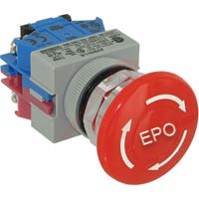
Example Emergency Power Off without guard present

Emergency Power Off guard with label present
Example Emergency Power Off with guard present

Appendix C Example Area Warning Sign

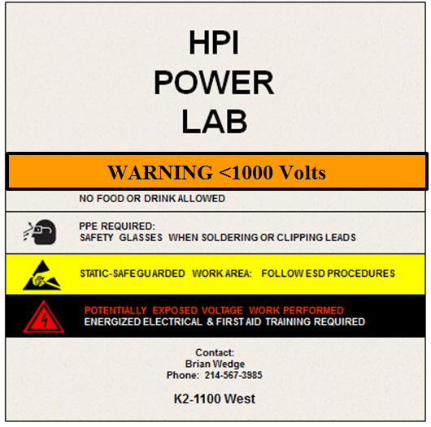

Appendix D Example Workstation Warning Signs

Where voltages greater than 1,000 volts are present they shall use the red “Danger” Sign
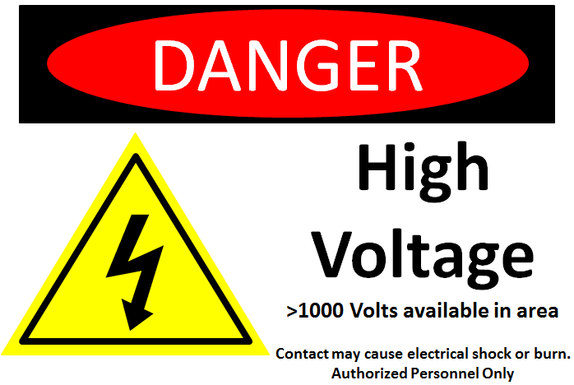

Voltages 1,000 volts or less use the orange “Warning” Sign
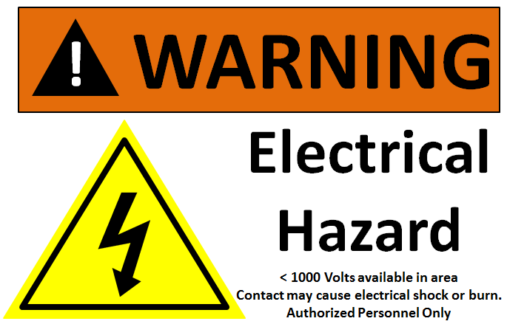

Appendix E Energized Work Procedure for Laboratory Use
Document Creator(s) |  |  |  |  |  |  |  |  |  |  |  |  |  |  | Date:
Document Reviewer(s) |  |  |  |  |  |  |  |  |  |  |  |  |  |  | Date:
Document Approver(s) |  |  |  |  |  |  |  |  |  |  |  |  |  |  | Date:
Identification of equipment/tool (Make/Model):
Identify the training required for this procedure:
Statement of the work to be performed
(For example, the tasks may include routine measurements, calibrations, or testing of circuits):
Location of workstation(s) where procedure applies
Voltage(s) present: |  |  |  |  |  |  |  |  |  | Ampere Rating of power supply:
Description of Hazard |  |  |  |  |  | Method to Avoid |  |  |  |  |  | Personal Protective Equipment
 |  |  |  |  |  |  |  |  |  |  |  | Eye/Face |  |  |  | Hand |  |  | Arm | Foot
Identified hand protection for working on energized part:  (This PPE must be worn as long as the exposed energy is present)  Class 00 Gloves 250V AC and 375V DC, Class 0 Gloves 500V AC and 750 DC |  |  |  |  |  |  |  |  |  |  |  | Class:
Verify all personal protective equipment is in good working condition, qualified for voltage to be serviced and is functioning properly.
List of specific precautions to be taken prior to start of the energized work
1.
2.
3.
4.
5.
6.
7.
8.
9.
Tools required to perform work |  |  |  |  |  |  | Volt Meter |  |  |  |  |  |  | Digital Volt Meter
 |  |  |  |  |  |  | Non-Conductive hand tools |  |  |  |  |  |  | Drill
 |  |  |  |  |  |  | Temp Guards/Shielding Material |  |  |  |  |  |  | Barrier Tape
 |  |  |  |  |  |  | Other
Attach drawings, datasheets, or illustrations indicating location of specific hazards
Name of Qualified Person(s) |  |  |  |  | (Print)
Name of Safety Back-up(s) |  |  |  |  | (Print)
Energized Work Approver |  |  |  |  | (Print)
Procedure Revision History
Revision Name |  | Changes Made |  |  |  |  |  |  |  |  | Date |  |  |  |  |  | Approval

